A.
<h1>This is a Main Heading</h1>
<h2>This is a level 2 heading</h2>
<h3>This is a level 3 heading</h3>
<h4>This is a level 4 heading</h4>
<h5>This is a level 5 heading</h5>
<h6>This is a level 6 heading</h6>

B.
<p>A paragraph consists of one or more sentences that form a self-contained unit of discourse. The start of a paragraph is indicated by a new line.</p>
<p>Text is easier to understand when it is split up into units of text. For example, a book may have chapters. Chapters can have subheadings. Under each heading will be one or more paragraphs.</p>

C.
<p>This is how we make a word appear <b>bold</b>.</p>
<p>This is how we make a word appear <i>italic</i>.</p>

D.
<p>On the 4<sup>th</sup> September you will learn about E=MC<sup>2</sup>.</p>
<p>The amount of C0<sub>2</sub> in the atmosphere grew by 2ppm in
2009<sub>1</sub>.</p>

E.
<p>The moon is
drifting away from the
earth.</p>
(Multiple spaces get collapsed into a single space.)
F.
<p>The Earth<br />gets one hundred tons heavier every day<br />due to falling space dust.</p>

G.
<p>Venus is the only plant that rotates clockwise</p>
<hr />
<p>Jupiter is bigger than all the other planets combined.</p>

H.
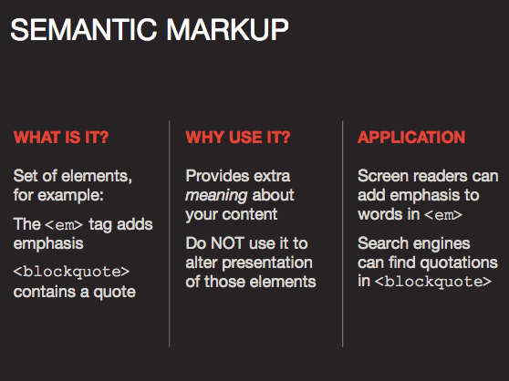 p. 50

<p><strong>Beware</strong> pickpockets operate in this area.</p>
<p>I <em>think</em> Ivy was the first.</p>
<p>I think <em>Ivy</em> was the first.</p>
<p>I think Ivy was the <em>first</em>.</p>

I.
LISTS
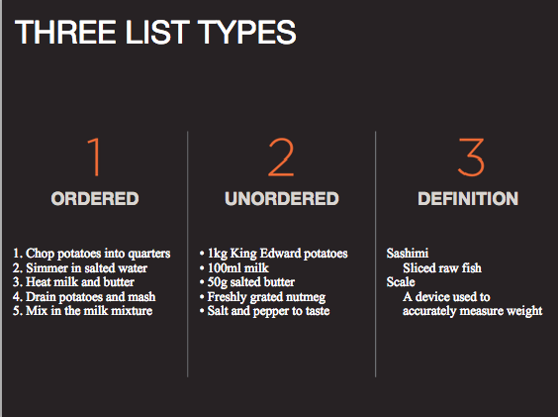

Ordered List

<ol>
<li>Chop potatoes into quarters</li>
<li>Simmer in salted water for 15-20
minutes until tender</li>
<li>Heat milk, butter and nutmeg</li>
<li>Drain potatoes and mash</li>
<li>Mix in the milk texture</li>
</ol>

Unordered List (aka bullet points)

<ul>
<li>1kg King Edward potatoes</li> <li>100ml milk</li> <li>50g salted butter</li> <li>Freshly grated nutmeg</li> <li>Salt and pepper to taste</li>
</ul>

Definition List

<dl>
<dt>Sashimi</dt> <dd>Sliced raw fish served
with condiments.</dd> <dt>Scale</dt> <dd>Device used to measure the weight of ingredients.</dd> <dd>A technique by which the scales are
removed from the skin of fish. </dd></dl>

Nested List

<ul>
<li>Mousses</li>
<li>Pastries</li> <ul>
<li>Croissant</li>
<li>Milles-feille</li>
<li>Palmier</li>
<li>Profiteroles</li>
</ul>
<li>Tarts</li>
</ul>

