Heroic Realism (1918-today)

Heroic Realism ()
Born in Russia…and from Lenin’s own agenda to shock the Russian people out of their backwardness (and b/c he didn’t trust the Constructivists)
Posters became a direct medium for educating the illiterate peasant in almost every aspect of everyday life.
Adolf Hitler’s National Socialist Party also embraced Heroic Realism to combat avant garde influences…so Heroic Realism is a response to the perceived elitism of modernism (Hitler outlawed modern sans serif typeface in favor of the medieval German Fraktur!)
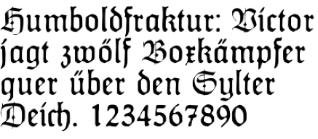
(and then b/c Fraktur was so illegible, he outlawed that, claiming it was a Jewish invention)
So the Heroic style was primarily a tool for dictatorships (although both sides of the Spanish Civil War used this style as well)
Advertising and editorial illustration in Western industrial democracies has often employed romantic realism as a timeworn means of enhancing a product or idea in the consumer’s eye.
Used during wartime (WWII) in the U.S. and England
Heroic Realism as an official graphic style still prevails in Soviet countries.

THEMES  Idealized scenes of leaders and workers  Romantic depictions of the Aryan Superman  Overbearing images of “Aryan beauty” | DESIGNS  Staid typographic treatments  Figurative painting  Some photography and montage

